The JRS

2020-04-08

ENSE 471

How to Use the Fire Safety App

**Installation:**

Before the app can be used, it needs to be installed. Please follow the installation instructions at the link <https://github.com/RayK3/ENSE471-Project/tree/master/fire-safety>

**Note:** All pictures included in this document were taken from the web version of the app. The app is meant to be run on a mobile device, so the proportional sizes of different components in this document are not accurate to how they will look on a phone.

**Home Screen:**

When the app is started, the first screen loaded is the phone interface. This is where the kids will practice inputting 911. On the bottom of the page, indicated by the red rectangle, is the main navigation bar. It allows access to the three main components of our app: the phone display, the list of questions, and additional information.

Picture 1: Home screen phone display with bottom navigation bar

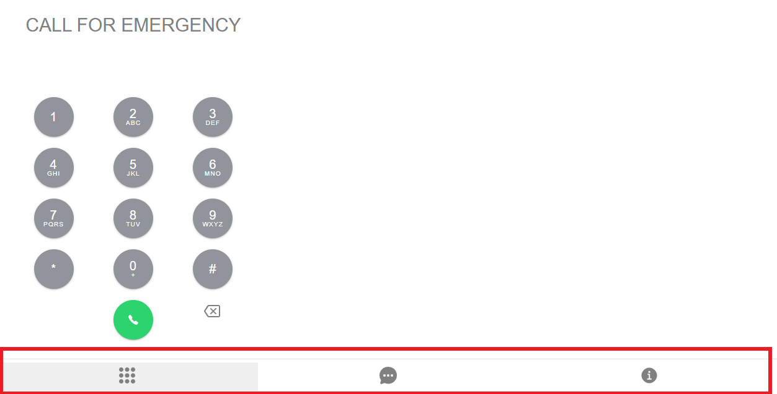

The phone display itself was created to look as similar as possible to the phone display of an iPhone. The letters under the numbers aren’t functional, and are exclusively to make the display look and feel more accurate.It is worth noting that the interface does not allow more than three numbers to be entered.

Picture 2: The phone interface

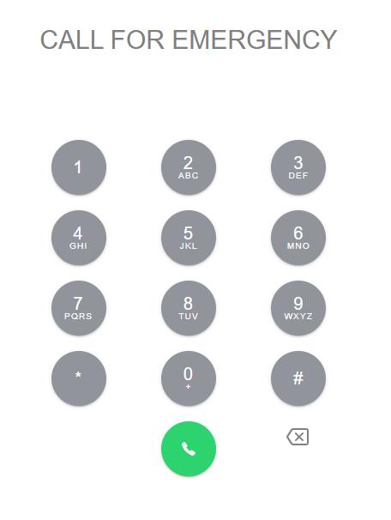

**Try Again:**

When a child clicks the green ‘call’ button with anything other than 911 entered. They are taken to our encouraging try again page. This page has a built in 3-second timer that will return the child to the 911 interface.

Picture 3: The try again page



**Good Job:**

If instead, the child enters 911 and clicks the ‘call’ button, they are taken to our good job display. This screen contains five stars. As the child goes through the question answering process, these stars fill up to show their progression. The first star is filled from calling 911, and the remaining four are filled by answering questions correctly.

Picture 4: Child entering 911

Picture 5: Good job display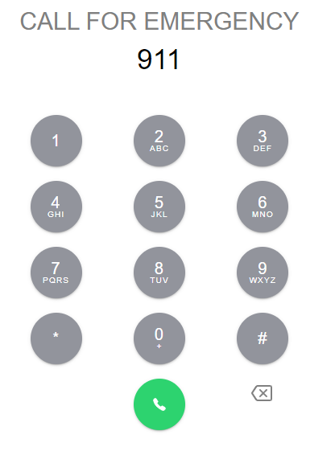

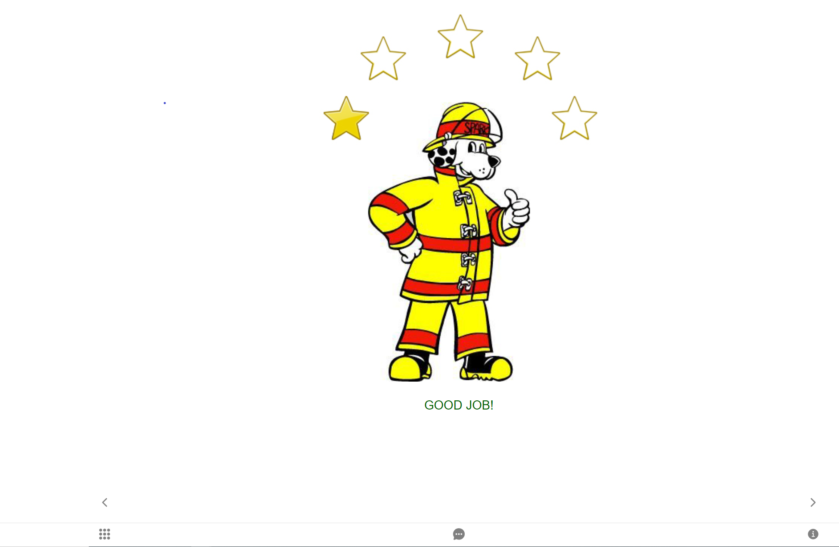

**Questions:**

After clicking the small right arrow at the bottom of the good job display, the child will be guided through the four questions that a 911 operator will ask. The first question in its display is presented below. The app requires a child or parent/firefighter to click the next button to traverse through these questions. It also assumes that the child has answered them correctly. When the child has answered all four questions correctly, the app takes them back to the 911 display.

Picture 6: First question asked by 911 operator

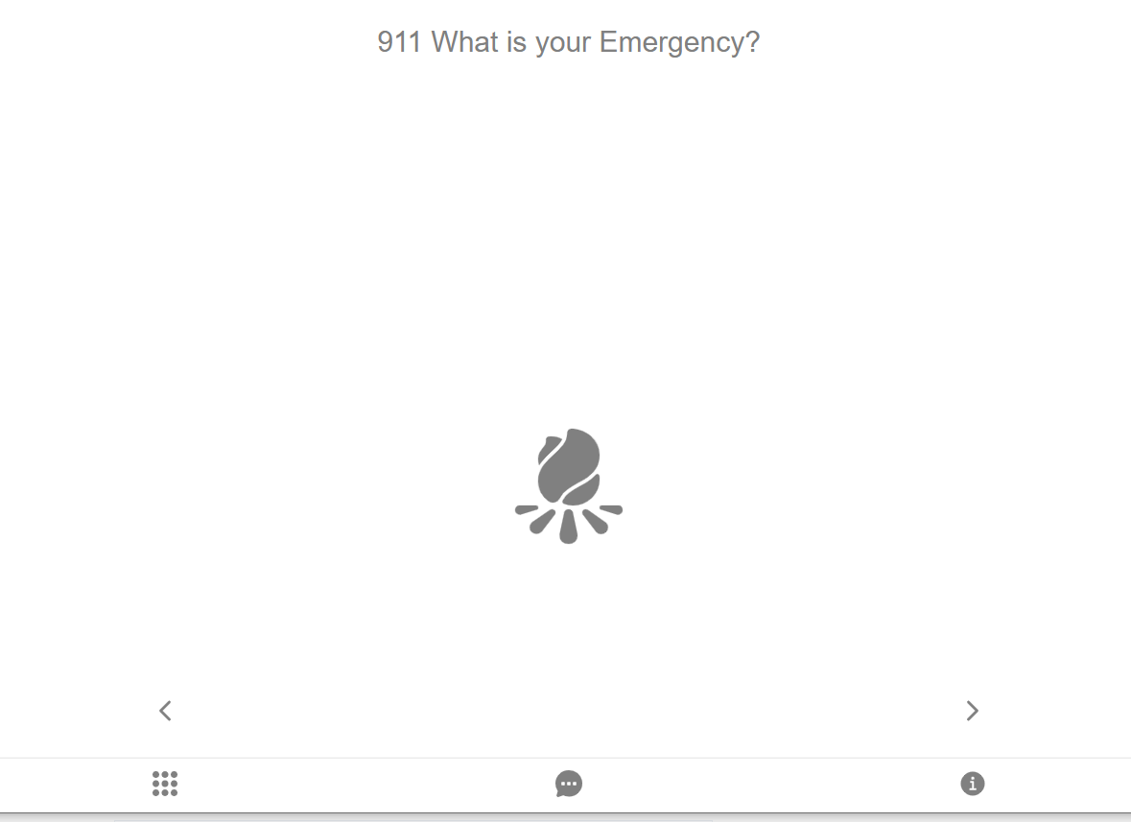

**Question List:**

The second main portion of our app is the list of the four questions that are asked within the 911 dialogue with the children. This is accessed through the middle element of the bottom navigation bar. This is meant to be a simple display where a parent or firefighter can view all of the questions in one place.

Picture 7: List of questions asked by 911 operator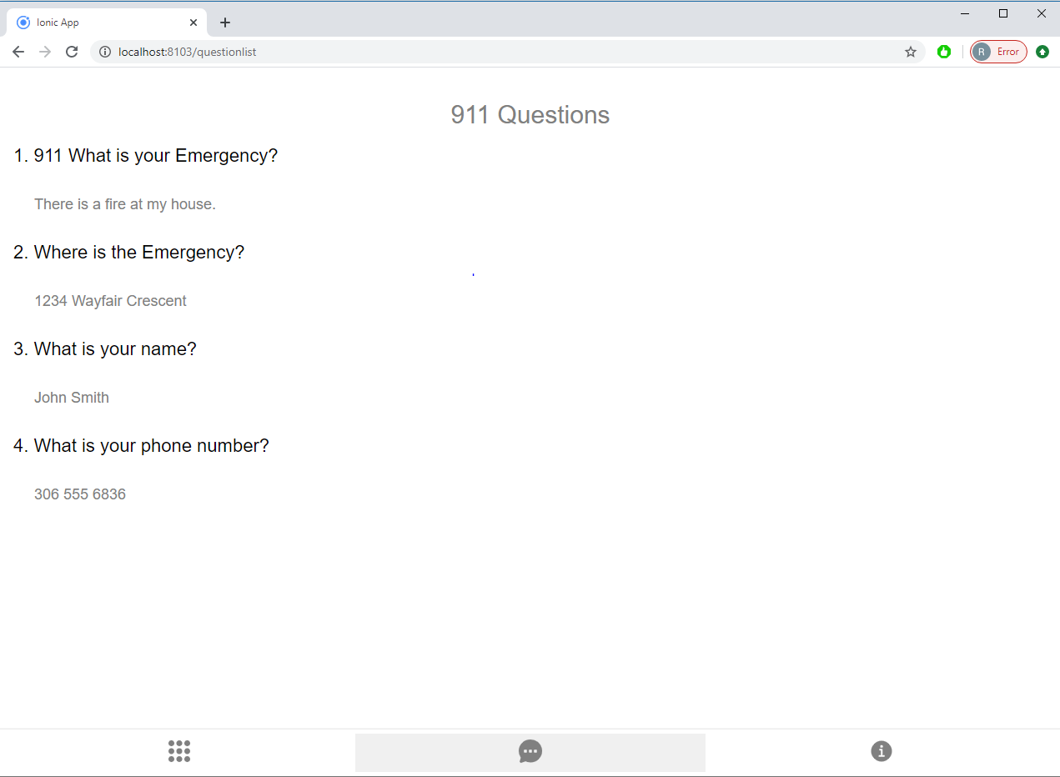

**Info Page:**

The third and final portion of our app is the additional fire safety info that we included. This is accessible via the last (furthest right) icon in the bottom navigation bar. When a user clicks on this icon, they are taken to the main info screen. Here, they can choose to see some fire escape plan pictures, training cards used in demonstrations, or additional questions that a 911 operator could ask.

Picture 8: The main info screen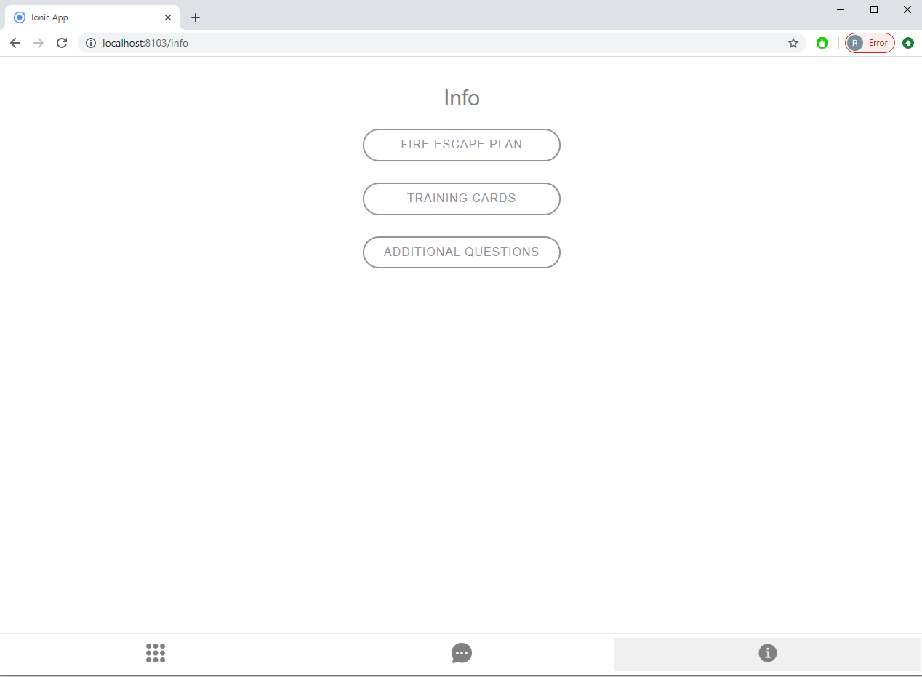

**Fire Escape Plan / Training Cards:**

The first two links on the main info page take the user to a display of fire-escape-plan pictures or a list of training cards. These pictures were provided by Candace for use within the project.

Picture 9: Fire escape plan page Picture 10: Training Cards

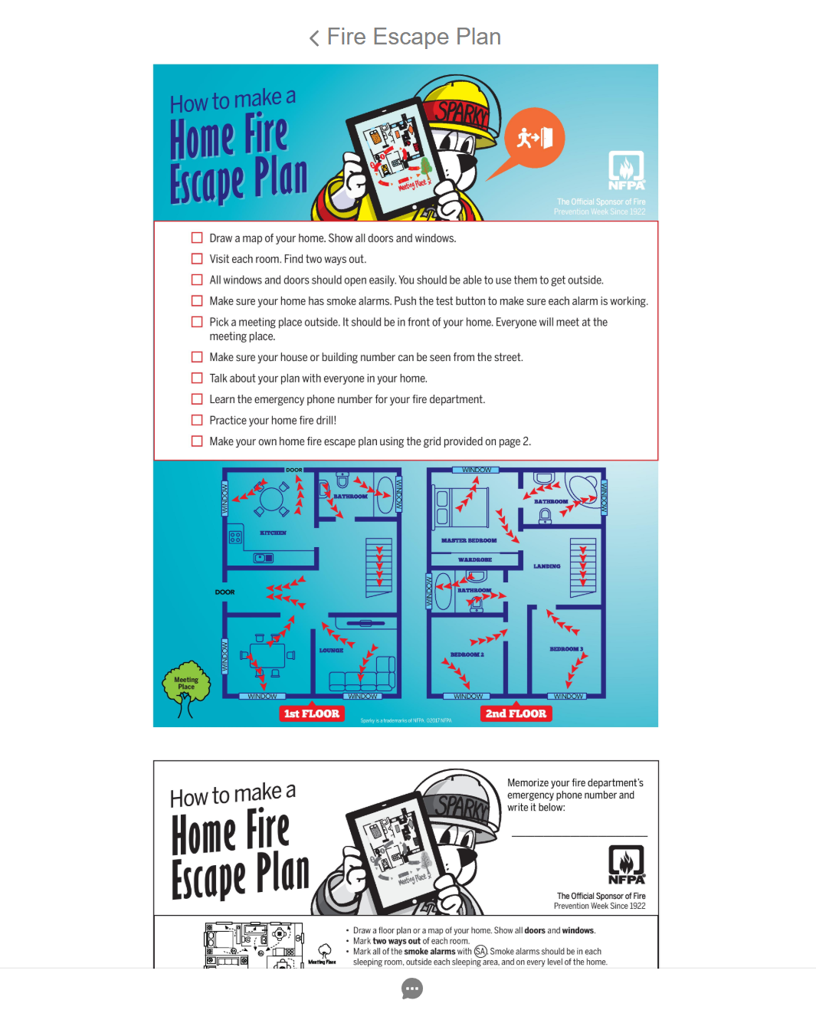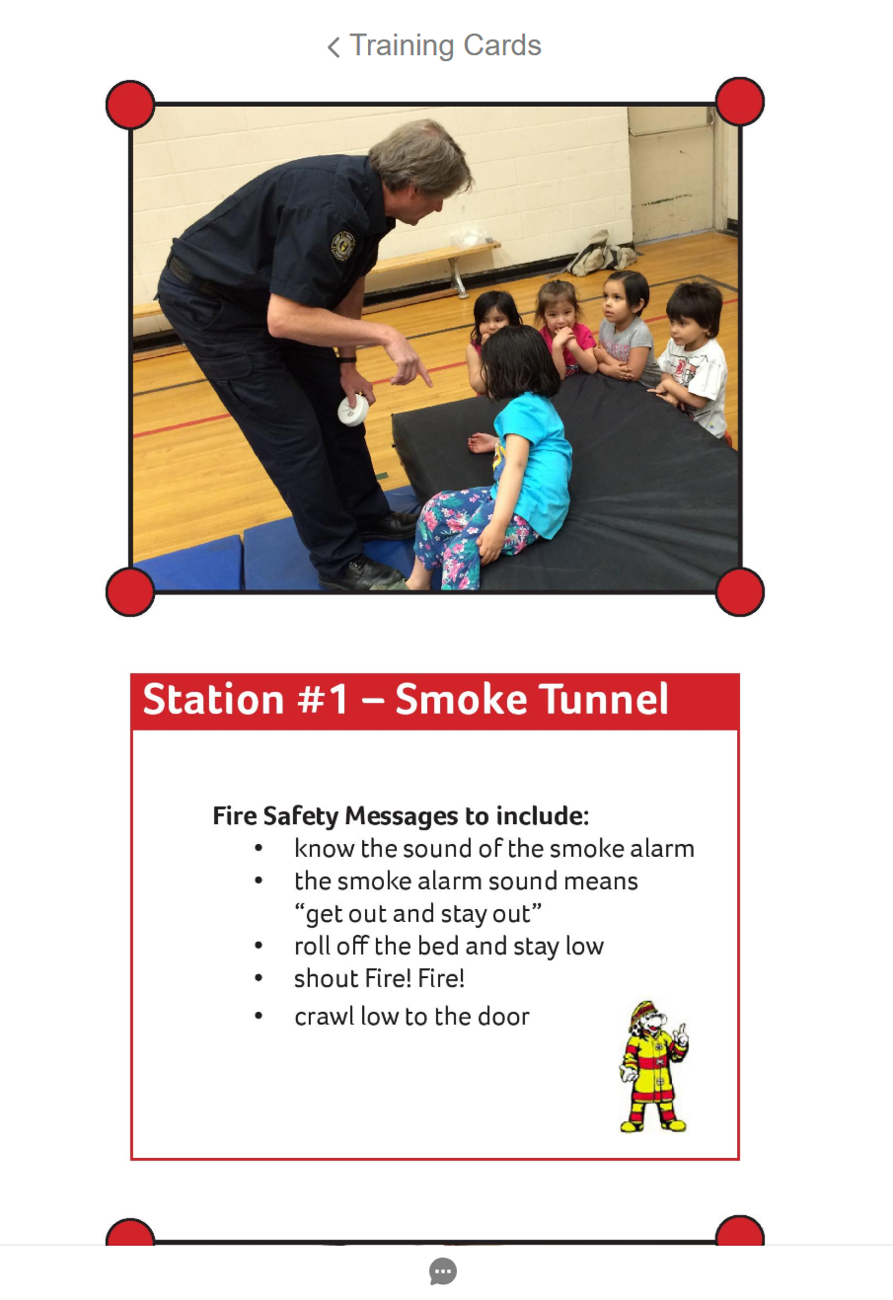

**Additional questions:**

The third link in the info section of the app takes a user to a list of additional questions that a 911 operator could ask in varying scenarios. These were sourced from <https://www.saskatchewan.ca/residents/emergency/sask911#911-safety-tips> which was also provided by Candace.

Picture 11: Additional 911 operator questions